Social Listening Report: Q2 April - June 2025

Executive Summary

This report presents the findings of a comprehensive social listening study conducted to analyze social media conversations across East and Southern Africa (ESA) related to the topics of sexual and reproductive health and rights (SRHR). Using a methodology grounded in qualitative and quantitative social media analysis, the research identifies key trends and narratives, country-specific nuances, as well as the risks and opportunities for UNICEF and partners associated with these critical topics. The report aims to inform actionable recommendations for advocacy and communication strategies to support objectives in the region. Please note that any views reported on as part of the social media landscape analysis do not necessarily reflect the views of UNICEF or partners.

Methodology

This social listening and community insights study was conducted in July 2025, covering three months of data between April and June 2025 across the Eastern and Southern Africa region in five languages (English, Portuguese, French, Arabic and Swahili).

Research questions. We aimed to answer the following questions:

- What trends and issues are the most and the least visible online and in the media?
- What positive and negative narratives are emerging online?
- Misconceptions and Disinformation: what barriers exist to promote programme responses?
- What is the tone and language used to describe all issues selected?
- Which individuals and entities are shaping the debate?
- What are the major behavioral and communications risks, and opportunities to act based on insights provided in the report.
- Which resources can be used to provide a response?

The study employed social listening and community feedback data to analyze concerns, questions and potential misleading and harmful content from the public. Social listening tool “TalkWalker” and community insights research were used to capture relevant conversations across target countries, with thematic categorization and sentiment analysis applied to structure the findings. While the dataset is extensive, the study acknowledges limitations, including restricted access to private data and potential bias inherent to social listening and community insights research.

This report is produced with support from 2gether 4 SRHR, a joint UN Regional Programme, in partnership with Sweden, which brings together the combined efforts of UNAIDS, UNFPA, UNICEF and WHO to improve the sexual and reproductive health and rights (SRHR) of all people in Eastern and Southern Africa. For a one stop shop of information and resources in Africa, visit the SRHR Knowledge Hub.

Key findings on Sexual and Reproductive Health and Rights (SRHR) in Q2 of 2025:

- Sexual violence and GBV triggered important online engagement, with unified calls for justice and accountability, particularly in South Africa, Zambia, and Kenya.
- Menstrual health narratives grew stronger, linking stigma reduction and mental well-being to dignity, male engagement, and policy innovation.
- SRHR-related disease prevention conversations emphasized adolescent outreach, STI awareness, and concern over misinformation and access gaps.

Conclusion

Across the ESARO region, social media discussions reflected both resilience and frustration. Child protection, SRHR, and education are deeply interconnected, with online voices demanding justice, inclusion, and system-level reform. These insights provide UNICEF with a timely opportunity to scale community-driven efforts, strengthen policy advocacy, and counter misinformation through context-specific, youth-centred strategies.

Research Findings SRHR

- Topical trends

Summary of results: Social listening insights around SRHR topics revealed a strong focus on issues of sexual assault, health, and adolescent pregnancy. Discussions on sexual assault emphasized victim support and mental health, with calls for stronger protective legislation. Health-related conversations highlighted regional priorities in HIV prevention, youth empowerment, and reproductive rights. Discussions on adolescent pregnancy stressed the need for comprehensive sex education and public health support. SRHR-related topics generated 48K mentions for a total engagement of 4.7M.

Graph 1: Tags by mentions (Bar chart)

The graph above illustrates the share of voice per topic over the analyzed period

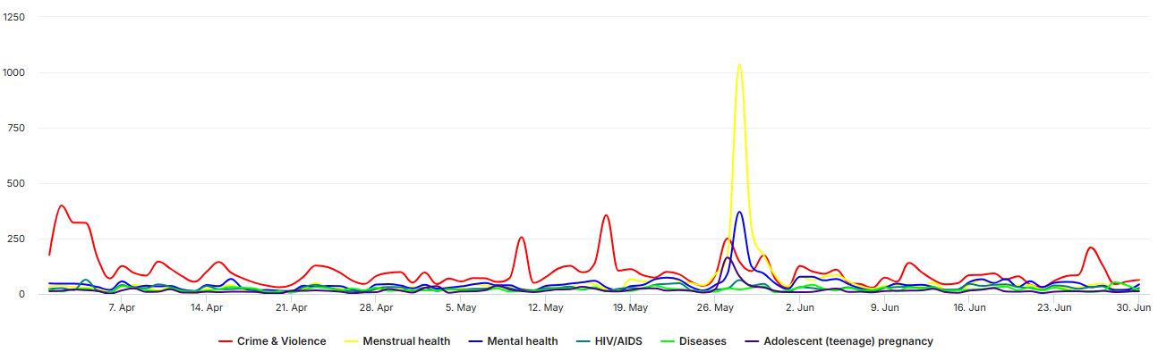
Graph 2: Tags over time (timeline chart)

The graph above illustrates the number of mentions attributed to each topic over the analyzed period

Trend A: Crime and violence in relation to SRHR

Overview: Online conversations across the region highlighted widespread outrage over sexual violence, with users demanding justice, legal reform and stronger survivor protection. Public responses ranged from protests and petitions to solidarity campaigns, with posts consistently exposing institutional failures and calling for urgent accountability. These narratives generated 9K mentions for a total of 792K in engagement.

Top engaging posts:

The most engaged posts reflected both solidarity with survivors and deep public divisions. In South Africa, a post linked ‘Sexual Assault Awareness Month’ to the country’s unfulfilled promise of freedom, raising awareness about GBV (link). In Zambia, a post denounced rape and child defilement, echoing widespread calls for child protection (link), while the ‘Stop GBV Now’ campaign gained traction across the region (link1, link2).

Country-specific nuances: Users expressed outrage over sexual violence, with each context revealing distinct justice gaps and public responses. South Africans condemned institutional failures after high-profile acquittals, while Kenyans mobilized around protests and rare convictions. Zambians led coordinated marches and petitions demanding harsher penalties. In Uganda, acquittals sparked legal debates on defilement, and a self-defense case involving a teenage girl drew sympathy. Zimbabweans amplified survivor voices through solidarity actions and campaigns against stigma, while Namibians reacted to a surge in graphic cases and official data showing thousands of GBV incidents, fuelling calls for systemic reform.

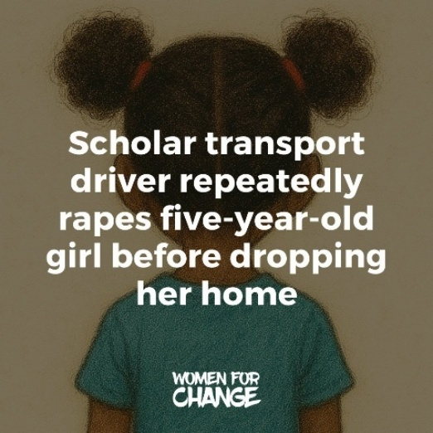
  - South Africa: Users expressed outrage over widespread sexual violence against children and women, amplified by repeated justice system failures. The acquittal of televangelist Timothy Omotoso despite 63 charges and the dismissal of the ‘Cwecwe’ child rape case due to lack of evidence triggered widespread disbelief and outrage (link1, link2, link3, link4). Reports included the rape of a 5-year-old girl in a school transport vehicle, the assault of an 11-year-old left in critical condition, and cases involving clergy, police officers, and even parents as perpetrators (link1, link2, link3, link4). Posts also flagged alarming statistics on teen pregnancies (link).

  - Kenya: Users rallied around survivors and condemned the weaponization of sexual violence, with posts sharing a rape support hotline during recent protests (link1, link2, link3). A 97-year-old man was convicted of defilement after impregnating an 18-year-old girl, sparking online outrage (link). In another widely shared case, two men were sentenced to death for gang-raping a woman and her cousin in Laikipia (link1, link2). While some posts promoted SRHR and GBV prevention efforts through local programs in Kisumu and Vihiga, many users expressed anger over persistent impunity and lack of protection for women and girls (link).

  - Zambia: Community members across provinces united in ‘Stop GBV Now’ protests and petitions, from Lusaka streets to Solwezi’s formal petition for harsher defilement penalties, demanding removal of bail for rape and defilement offenders (link1, link2, link3, link4). Civil society groups like NGOCC organized nationwide peaceful marches calling for no bond, stiffer sentences, and legal reform (link1, link2, link3). Many users engaged in the same way by expressing anger and outrage and calling for more justice for child defilement cases (link).

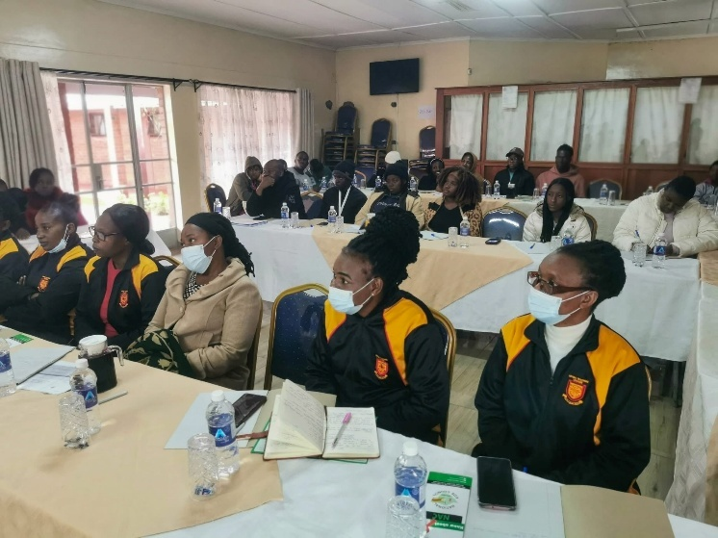
  - Uganda: Users condemned the case of a 17-year-old girl charged with murder after allegedly killing her husband in self-defense during a rape attempt, calling for her release and highlighting the dangers of forced child marriage (link). Outrage also followed the acquittal of three minors accused of rape, triggering judicial debates around prosecution for rape versus defilement, as recently introduced in the Uganda law (link1, link2, link3, link4, link5, link6, link7). The conviction of a teacher for defiling six students was welcomed, with users praising the 46-year sentence as a rare act of justice (link).

  - Zimbabwe: Outrage erupted over the public trial of influencer Mai Jeremaya, with activists demanding tougher penalties, better survivor support, and an end to victim-blaming after she waived anonymity to recount her rape (link1, link2, link3). Stories of women escaping an alleged attempted gang-rape, prompted calls to regulate traditional healers and protect vulnerable women (link). Solidarity actions—declarations of “Black Friday” in support of survivors and “Stop GBV” protests underscored a movement to dismantle rape culture and hold perpetrators accountable (link1, link2). Various accounts highlighted the ‘Denim Day’, aiming to challenge stigma and amplify survivor voices (link1, link2, link3). Meanwhile, other users questioned prosecutorial overreach in sex-trafficking charges, urging that cases of violence against women be charged appropriately as sexual assault or defilement to secure convictions (link).

  - Namibia: Namibia’s ‘GBV crisis’ sparked national outrage, with posts warning the country ranks among the worst globally for violence against women and girls (link1, link2). The rape and murder of a 17-year-old drew a presidential plea to end ‘vicious acts’ and raised fears of a serial offender (link1, link2, link3). A minister accused of raping a minor was dismissed and placed under investigation, while other reports included women with developmental disabilities pregnant after assaults and children disclosing abuse (link1, link2, link3). A rape case was dismissed due to failed identification, highlighting justice gaps (link). Amid praise for a woman who fought off a rapist, official data revealed ‘4,405 GBV’ cases within 11 months, fueling calls for survivor protection (link1, link2, link3).

Trend B: Menstrual and mental health

Overview: Menstrual health conversations across the region highlighted male involvement, policy reform, and stigma reduction, with strong institutional action in Uganda and Zambia and a medicalized focus in Tanzania. Mental health was consistently linked to menstrual well-being, while top posts featured outreach events, traditional remedies, and calls for free pads. These narratives generated 7.5K mentions for a total of 670K in engagement.

Top engaging posts: A South African radio segment encouraged male involvement in menstrual health through a period pain simulation by a male host (link). In Kenya, Softcare held an outreach at a women’s prison linking menstrual education to mental well-being (link). A Tanzanian herbalist explained how changes in vaginal discharge can signal fertility or infections, urging medical attention when necessary (link). In Madagascar, a post marking ‘Menstrual Hygiene Day’ called for free distribution of sanitary pads, comparing their necessity to that of condoms (link).

Country-specific nuances: In Kenya and South Africa, advocacy emphasized dignity, policy reform, and male involvement, with Kenya highlighting workplace protections and South Africa linking stigma to toxic masculinity. Uganda and Zambia showed stronger institutional engagement, with Uganda focusing on national guidelines and donor-backed outreach, while Zambia advanced infrastructure and stood out with its menstrual leave policy. Tanzania’s conversations were more medicalized, centered on hygiene, testing, and natural remedies. Mental health was integrated across all contexts, often tied to stigma reduction, trauma, and menstrual well-being.

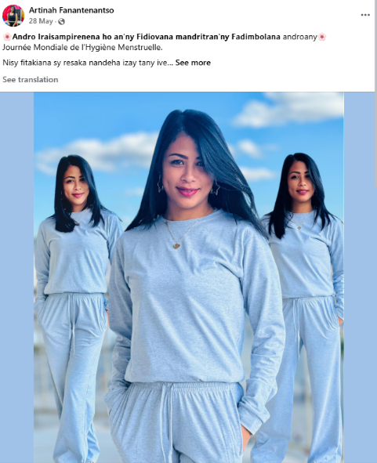
- Kenya: Online conversations surged around ‘Menstrual Hygiene Day and Month’, with widespread calls to end period stigma and poverty (link1, link2, link3, link4). Influencers, government actors, duty bearers and local leaders promoted dignity in the context of menstrual health (link1, link2, link3). Discussions emphasized not only product distribution but also policy gaps, including the need for menstrual leave and workplace protections (link1, link2). Mental health was also linked to menstrual well-being, with organizations and youth-led podcasts addressing the psychosocial impact of menstruation (link1, link2, link3).

- South Africa: Menstrual and mental health gained widespread attention through campaigns emphasizing dignity, access, and inclusion with media outlets and health professionals promoting male engagement to break period stigma (link1, link2, link3). Political actors and student bodies called for policy reform and free sanitary products (link1, link2), while outreach efforts by NGOs reached schools and rural communities (link1, link2). Mental health narratives focused on trauma healing and challenging toxic masculinity, especially among youth (link1, link2). On the other hand, several pages promoted natural remedies for hormonal health, wellness, and spiritual care (link1, link2).

- Uganda: Narratives emphasized dignity and access, with celebrities and influencers distributing reusable pads and breaking taboos through community outreach and online campaigns (link1, link2). Policymakers rolled out Menstrual Health Guidelines for schools while political figures and Rotary donors committed funding (link1, link2, link3, link4). Youth-led movements mobilized communities to provide safe spaces and sanitary supplies (link1, link2, link3). Mental health was integrated as central to SRHR, with advocates highlighting the emotional impact of menstruation and challenging toxic cultural norms (link1, link2). Herbal wellness brands promoted hormonal alternative remedies (link1, link2).

- Tanzania: Conversations on menstrual health focused on medical guidance, hygiene practices, and the need for greater male involvement with health experts and clinicians offering advice on early pregnancy symptoms and detox routines (link1, link2). Influencers also emphasized proper pad use and intimate care to prevent infections, while hormone and thyroid testing to address irregular cycles was promoted (link1, link2). Advocates called for broader STI screening and supportive roles for men (link). Alongside these, herbalists popularized natural remedies for menstrual pain and fertility (link).

- Zambia: Narratives focused on policy progress as the Ministry of Education committed to menstrual-friendly infrastructure and training, while Zambia’s ‘menstrual leave’ policy continued to draw regional attention (link1, link2). Youth advocates promoted school and community outreach through mentorship and peer-led SRH sessions, supported by campaigns like ‘herhealthzambia’ and pad drives by university unions and radio stations (link1, link2, link3, link4). Clinicians raised awareness of conditions and the need for tailored care, while digital forums highlighted links between menstrual poverty and HIV risk (link1, link2). Some posts also emphasized mental health, stigma reduction, and early detection of cervical and breast cancer (link1, link2, link3).

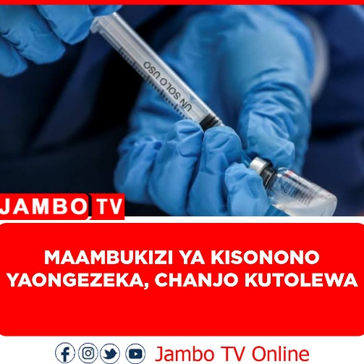
Trend C: Diseases

Overview: Online discussions across the region focused on STI prevention, youth education, and access to care, with growing concern over rising infections, misinformation, and service gaps. Countries emphasized condom use, PrEP and PEP education, and adolescent outreach, while also highlighting institutional failures, funding challenges, and the spread of unverified traditional remedies.

Top engaging posts: Posts promoted condom use in Kenya to prevent HIV, STIs, and unplanned pregnancies (link). In Zambia, a defilement case involving HIV transmission to a child drew public anger after the suspect’s wife died in custody amid bribery claims, while a South Africa-based programme showcased how SRHR sessions helped youth build leadership and advocacy skills (link1, link2). In Burundi, a health post emphasized the role of HPV vaccination in preventing cervical and other cancers (link).

Country-specific nuances: Across countries, conversations reflected a mix of clinical education, stigma reduction, and urgent service gaps. Tanzania and South Africa saw strong peer-led STI education, with South Africa also highlighting sexual violence and destigmatization efforts. Kenya and Uganda emphasized condom use, biomedical prevention, and concerns over funding cuts impacting adolescent services. Zambia's focus combined outrage over abuse cases with expanded outreach, while Zimbabwe highlighted high STI rates and efforts to scale up integrated SRH and HIV services in high-burden areas.

- Tanzania: Online conversations were dominated by peer education content on STIs, with many posts explaining symptoms, causes, and clinical advice for infections (link1, link2, link3). Posts highlighted fungal and bacterial infections, often linked to UTI and poor hygiene practices (link1, link2). Official pages and media posts emphasized national health priorities, linking maternal mortality to poor SRHR services and calling for stronger STI prevention and adolescent reproductive health education (link1, link2, link3). A noticeable number of health influencers and herbalists promoted traditional remedies for chronic infections, infertility, and menstrual disorders, often presenting unverified treatments as safer alternatives to clinical care (link1, link2, link3).

- South Africa: Posts highlighted prison sexual violence underscoring HIV risk and family rape cases leading to severe STI-related complications (link1, link2). A push emerged for destigmatization, with influencers urging open dialogue on HIV status and STI testing (link1, link2). Health services and advocacy groups promoted symptom awareness and screening (link1, link2, link3, link4). Youth programmes focused on empowering adolescents with SRHR knowledge through community-driven talk shows and peer networks (link1, link2). Other posts endorsed herbal remedies, presented as fertility and STI prevention aids (link).

- Kenya: Conversations wove strong public health advocacy—promoting condom use for HIV/STI and pregnancy prevention, PEP education to counter misinformation, and comprehensive clinic services—with urgent warnings that USAID funding cuts could trigger rises in unintended pregnancies and STIs (link1, link2, link3, link4, link6, link7). Educational content clarified clinical nuances, distinguishing UTIs from STIs, while reports highlighted approved HIV prevention injections and a world-first gonorrhea vaccine rollout (link1, link2, link3). School-based SRH training was spotlighted as vital for youth empowerment, alongside calls to normalize regular testing and self-care as acts of self-love (link1, link2). Finally, a study revealing high chlamydia and gonorrhea prevalence among adolescents (link).

- Uganda: Posts promoted condom use to reduce HIV and STIs and corrected misinformation by clarifying that UTIs are not sexually transmitted (link1, link2). Influencers explained biomedical options, with health professionals addressing PEP side effects and outlining how PrEP and PEP work (link1, link2). Advocacy groups flagged systemic challenges such as high adolescent pregnancy, low HIV prevention knowledge among out-of-school youth, and the impact of USAID funding cuts on stigma-free care (link1, link2). New programmes were highlighted, including the 4-year ‘PROTECT’ initiative targeting teenage pregnancies and HIV, and school-based youth outreach on menstrual health and HIV prevention (link1, link2).

- Zambia: Cases of incest and defilement gained significant traction, some involving HIV transmission to minors, prompting calls for stronger law‐enforcement and child‐protection measures (link). Health authorities warned of rising syphilis rates among pregnant teenagers and urged consistent condom use and regular STI screening (link). Community‐driven podcasts and youth‐peer sessions tackled menstrual hygiene, mental well‐being, and reproductive health education (link). Mobile wellness expos and clinic outreaches offered free cervical cancer screening, HIV testing, and broader SRH services to bridge gaps in rural and urban areas (link).

- Zimbabwe: Zimbabwe’s HIV prevention framework emphasized layered protection through partner testing to achieve viral suppression (link). Harare reported over 25,000 new STI cases in 2024, exposing persistent gaps in condom availability and STI treatment (link1, link2). Peer-led mentorship programmes trained young people living with HIV to support reproductive health awareness and treatment adherence (link). Mobile clinics and school-based sessions expanded access to contraception, menstrual hygiene support, and HIV testing among adolescents (link). With adult HIV prevalence exceeding 14 percent in Matabeleland North, new national priorities have been announced, and include integration of TB, mental health, and SRH services in high-risk regions (link).

- Narratives

Summary of results: Social media discussions painted two starkly different pictures: one of collective empowerment and another of deep frustration with the failures of institutions charged with protecting sexual and reproductive rights.

Graph 1: Word cloud with sentiment filter
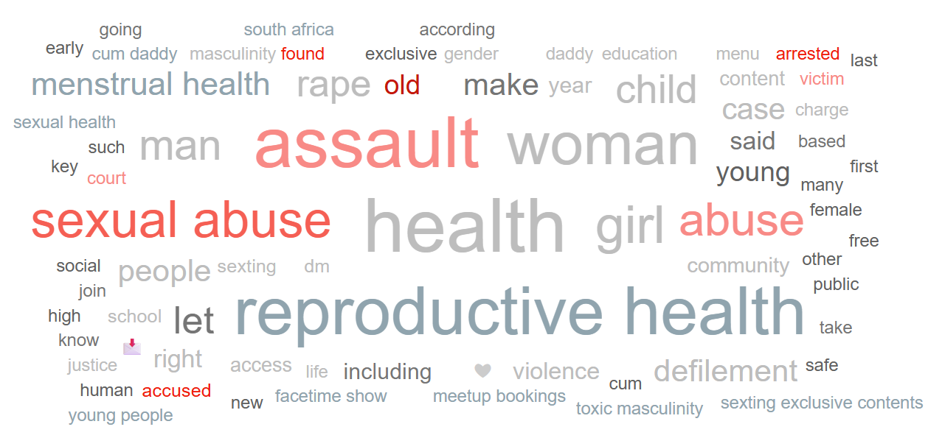

Positive narratives

Positive narratives celebrated grassroots efforts that promoted dignity, education and healing around SRHR issues:

- Kenya: advocates marked Menstrual Health Day inside Langata Women’s Prison, combining menstrual wellness workshops with mental-health discussions to uplift incarcerated women (link). The ‘DADA culture’ movement fostered peer support (link).
- South Africa: menstrual-hygiene campaigns equipped girls in schools and communities reusable sanitary kits, school-based awareness sessions and involvement of male allies to break taboos (link).
- Madagascar: Local efforts for SRHR were framed as a collective responsibility, fostering peer support and leadership skills among young women and men (link).

Negative narratives

Negative narratives reflected widespread frustration with judicial failures, institutional impunity, and the lack of protection for survivors:

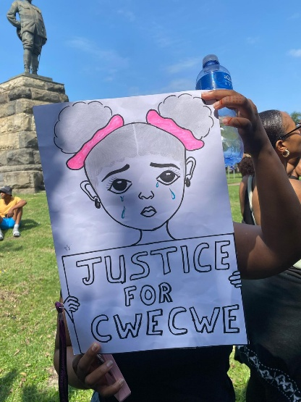
- South Africa: The acquittal of televangelist Timothy Omotoso on multiple rape and trafficking charges provoked outrage, with users questioning systemic bias and the credibility of the justice process (link1, link2). The National Prosecuting Authority’s decision to drop the sexual assault case of seven-year-old Cwecwe due to “lack of evidence” further deepened public mistrust (link1, link2).

- Zambia: Peaceful protests under the “Stop GBV Now” banner called for stronger sentencing and police accountability after repeated failures to address defilement and rape cases, particularly where minors were affected (link).

- Angola & South Africa: Graphic cases of child sexual abuse triggered horror and calls for urgent action. In Angola, a man was accused of raping a minor and deliberately transmitting HIV (link). In South Africa, a couple was arrested for producing child sexual abuse material involving their daughters, and another case involved a five-year-old repeatedly raped in a school transport vehicle (link1, link2, link3).

Misconceptions and Disinformation

Misleading claims and unscientific beliefs regarding sexual and reproductive health circulated, often disguised as cultural advice or natural remedies.

- Tanzania & South Africa: Several TikTok pages promoted natural remedies such as Moringa claiming that it enhances ‘sexual health’ (link1, link2).

- Influential stakeholders

Promoters of SRHR
Name | Channel | Followers | Link example(s) | Profile
Women for Change | X | 31K | Link | Nonprofit organization
Penuel The Black Pen | X | 116K | Link | Independent media
Njeri Wa Migwi | X | 37K | Link | Activist
Remmy Kangwa | X | 493K | Link | Public figure
Arica Kaguy | TikTok | 6.4K | Link | Artist/influencer
Christopher Buni | X | 17K | Link | Influencer
Vongai Mtsambiwa | TikTok | 1.6K | Link | Activist
Fadzayi Mahere | X | 845K | Link | Lawyer & public figure
Softcare Kenya | TikTok | 15.2K | Link | Business
Phannie Kwegah | X | 95K | Link | Lawyer & public figure
Dr Frank Mawenda | TikTok | 5K | Link | Health professional
Celestine Gachuhi | TikTok | 375K | Link | Influencer

Detractors of SRHR
Name | Channel | Followers | Link example(s) | Profile
ORGANIC SOLUTIONS | TikTok | 96.5k | Link | Promotes alternative medication
Thandi Condradinah | TikTok | 12.7K | Link | Promotes alternative medication
Lotuspes | TikTok | 177K | Link | Promotes alternative medication
Bashir Herbalist | TikTok | 50K | Link | Promotes alternative medication

- Potential risks and opportunities to act

Key question: What are the major behavioral and communications risks, and opportunities to act based on insights provided in the report.

Potential risks

- Widespread judicial failures, especially in South Africa, Zambia, and Uganda, could deter survivors from speaking out and fuel public mistrust in institutions.
- The promotion of herbal remedies for STIs, fertility, and menstruation in Tanzania and South Africa risks undermining clinical care.
- Despite strong links to SRHR, mental health needs remain under-resourced and may be deprioritized.
- Funding cuts in Kenya and Uganda threaten access to PEP, PrEP, and youth focused SRHR services.
- Misclassification of sexual crimes in Zimbabwe and Uganda could weaken legal outcomes and survivor protection.

Opportunities to act

- Grassroots and youth-led efforts across Uganda, Zambia, and Kenya offer strong platforms for rights-based SRHR outreach.
- Public outrage in South Africa and Zambia can be leveraged to push for legal reform and improved institutional accountability.
- High youth engagement creates momentum for expanding SRHR education and destigmatizing conversations.
- Collaborating with trusted influencers and clinicians offers a path to counter misinformation at scale.
- Strong regional focus on menstrual dignity presents an opportunity to promote policy change and integrated care

- Useful resources

- Guttmacher Institute – “Sexual and Reproductive Health in East and Southern Africa”
- EU Commission - Sexual and Reproductive Health and Rights (SRHR) in Sub-Saharan Africa
- Swedish government - Strategy for sexual and SRHR in Africa 2022-2026

Annex:
Taxonomy framework (Online social listening)

The construction of a comprehensive taxonomy related to SRHR was a crucial step in this research. It served as a tool to identify, categorize, and analyze the various elements of these themes in online conversations. This taxonomy served as a systematic categorization of key terms, concepts, and notions revolving around. The link to the following document shows the structure of the taxonomy used for this study. Access to topic framework here

Based on desk research, an initial list of key terms/words were identified. These keywords reflected what people say/share online and were then narrowed to ‘sub-topics’. Key words were broken down further into sub-topics. The list of key words/terms were shared with the relevant sections/focal points to review, amend, and add other relevant terms/searches based on the local context to ensure the quality of the taxonomy.

Data collection

The digital media ecosystem is comprised of digital news media, social media platforms, press agencies, forums/blogs, and search engines. These sources can be monitored using platform-specific or cross-platform tools. These tools can track social media conversations and other web pages according to the taxonomy.

Data sampling and testing

The data collection was carried out over a period of 3 months from 01 April to 30 June 2025. Importantly, the study only included publicly available content, respecting user privacy and ethical research standards.

The primary data source included online sources popular in the ESA region across 5 languages (English, Portuguese, French, Arabic and Swahili). These platforms range from social media networks such as Facebook, Twitter, TikTok and Instagram, to discussion forums, and blog posts.
This research also includes community insights made available by UNICEF teams. To ensure the reliability and validity of the data collected, a subset (5%) of the collected data was reviewed and coded by a social listening researcher.

Community insights research

This report integrates community insights research conducted on specific countries and issues. A sub-section summarizes the research findings that are used to inform recommendations. Note that community insight research may differ from social listening data in terms of period of analysis and scope.

